**ID: 488-24 E**

**Innovation & Groundbreaking Research**

**Radiative Power Beaming in the Millimeter Wave Regime**

**העברה אלחוטית של אנרגיה באמצעות גלים מילימטרים**

**Prof. Yosef Pinhasi**

Ariel University, Israel

[yosip@ariel.ac.il](mailto:yosip@ariel.ac.il) 054-7740201

Radiative power beaming is a technology for wireless energy transmission, offering a plethora of applications ranging from space exploration to terrestrial energy delivery. It involves the transfer of power through electromagnetic radiation, typically in the form of microwaves or lasers. Unlike conventional methods reliant on physical conductors, power beaming enables wireless energy transmission over distances without the need of using conducting cables. Among the applications, satellite and UAV's power supply, wireless charging of electronic devices and renewable energy harvesting.

Radiative power beaming faces several technical and practical challenges. These include optimizing overall power transfer efficiency, mitigating safety concerns associated with high-intensity radiation, and addressing regulatory and standardization issues. In order to achieve sufficient efficiency it is required to focus as much as possible the radiation intensity over the rectifying antenna (rectenna) converting the RF power into DC voltage.

At the millimeter wave (MMW) regime, at frequencies above 30GHz, the transmitting antenna presents high directivity at smaller apertures. However, the challenge emerges in the design of the rectenna and the necessity to utilize the appropriate diodes as rectifiers. This presentation reviews the different aspects of MMW power beaming, including propagation phenomena as well as available rectenna efficiency. Different configurations of MMW rectification are discussed, and experimental characterization of rectenna efficiency are presented. Simulation results will also presented to validate the proposed design methodology.

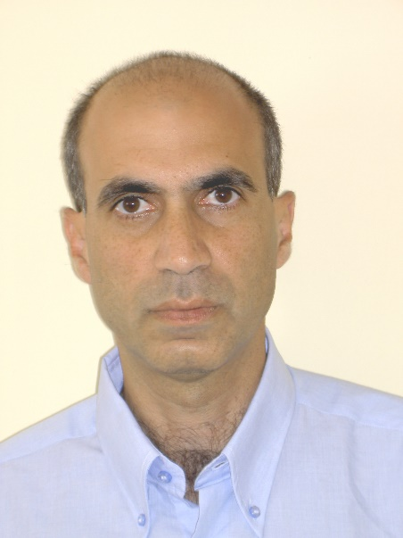

Yosef Pinhasi is a Professor in Ariel University. In 1995 he joined Ariel University as one of the founders of the Department of Electrical and Electronic Engineering, and served as its head between the years 2004-2007. During 2010-2017 he has been the Dean of the Faculty of Engineering at the Ariel University.

Since 1990 Prof. Pinhasi is working in the field of electromagnetic radiation, investigating mechanisms of its excitation and generation in high power radiation sources like microwave and millimeter wave electron devices, free-electron lasers (FELs) and masers. He developed a unified coupled-mode theory of electromagnetic field excitation and propagation in the frequency domain, enabling study of wideband interactions of electromagnetic waves in media in the linear and non-linear (saturation) operation regimes. He developed techniques for analyzing excitation and propagation of ultra-wide band signals in absorptive and dispersive media, including dielectric materials, as well as in distributed gain medium.

Prof. Pinhasi investigates utilization of electromagnetic waves in a wide range of frequencies for various applications such as wireless communications, stand-off detection, imaging and radars. The space-frequency approach, which developed by him, is employed to study propagation of wide-band signals in absorptive and dispersive media in broadband communication links, and wireless indoor and outdoor networks (including those in the EHF which are designed for the 5th generation of the cellular communications) as well as in remote sensing radars and radiative power beaming operating in the millimeter wavelengths and Tera-Hertz regimes.

Prof. Pinhasi is the head of the laboratory of wireless communications and radars, where Ph.D. and M.Sc. students are carrying their theses. He is radio amateur (call sign: 4Z1VC) and plays the piano and keyboards.